CHAPTER ONE
INTRODUCTION
1.1 General Introduction
The payment and management of school fees constitute an important administrative and financial activity in tertiary educational institutions. School fees provide a major source of internally generated revenue used by institutions to finance academic activities, maintain infrastructure, pay staff, provide student services, and support other institutional operations. Consequently, an effective system for collecting, recording, monitoring, and reporting school fees is essential for the efficient administration of any tertiary institution.
Traditionally, many educational institutions have relied on manual methods for managing school fee payments. Under such arrangements, students may be required to obtain payment tellers, visit designated banks or payment points, submit evidence of payment to the bursary department, and wait for the payment to be verified and recorded. Although this approach can function in institutions with a small number of students, it becomes increasingly inefficient as student enrolment and financial transactions increase. The uploaded project identifies problems associated with this approach, including loss of receipts, data inconsistency, long queues, reconciliation difficulties, and poor accountability.
Information and Communication Technology (ICT) has significantly changed the way organizations manage financial information. Computerized information systems can collect, store, process, retrieve, and present large quantities of information more efficiently than paper-based systems. In an educational environment, this makes it possible to automate important activities such as student registration, fee assessment, payment recording, receipt generation, balance calculation, and financial reporting.
A School Fees Payment Management System is therefore a computerized information system designed to support the complete school-fee payment process. The system provides a centralized database where student information, fee structures, payment transactions, and receipts can be stored and managed. Students can use the system to view their financial obligations, make or record payments, check their payment status, and obtain payment receipts, while authorized administrators can manage records and generate reports.
The adoption of electronic payment systems also supports transparency and accountability. Instead of relying exclusively on physical documents, payment information can be stored electronically and retrieved whenever required. Unique transaction or receipt numbers can be generated for individual payments, making it more difficult for fraudulent duplicate receipts to be introduced into the system.
The proposed system in this project uses HTML, CSS and JavaScript for the frontend, PHP for application development, and MySQL for database management. The original project adopts SSADM as the development methodology and provides modules for student management, fee management, payment recording, receipt generation, and administrative reporting.
The system is particularly relevant to polytechnic environments where large numbers of ND and HND students may need to complete fee payments within specific periods. By providing a computerized platform, the institution can reduce unnecessary queues, improve record keeping, simplify reconciliation, and make payment information available to authorized users.
1.2 Statement of the Problem
The traditional school fee payment system is associated with several problems that negatively affect students, bursary personnel, administrators, and institutional management.
First, the use of paper receipts and physical payment records creates the possibility of loss, damage, alteration, or forgery of payment evidence. Once a receipt is misplaced, retrieving the corresponding payment information may require searching through physical records.
Second, manual recording creates difficulties in payment reconciliation. Bursary personnel may have to compare bank documents, tellers, receipts, ledgers, and student records before determining the actual amount collected.
Third, students often experience long queues and delays, particularly during registration and fee-payment periods. Students may have to visit several offices before their payments are confirmed.
Fourth, the manual system provides limited ability to identify students with outstanding balances in real time. An institution may need to examine multiple records before determining which students have paid fully, partially, or not at all.
Fifth, manual records can expose institutional financial information to unauthorized access. Without adequate authentication, backup, and access-control mechanisms, confidential financial information may be compromised.
Sixth, manual systems make it difficult to produce timely management reports. Reports such as total fees collected, outstanding balances, daily collections, and lists of defaulters may require substantial administrative effort.
The uploaded project summarizes these challenges as loss and forgery of receipts, reconciliation difficulties, long queues, inability to track defaulters in real time, and poor data security and backup.
Therefore, there is a need for a computerized School Fees Payment Management System that will improve the efficiency, accuracy, security, accessibility, and accountability of school-fee administration.
1.3 Aim and Objectives of the Study
The main aim of this project is to design and implement a computerized School Fees Payment Management System that will automate the management of student fee information, payment records, receipts, and financial reports.
Objectives
The specific objectives are to:
- Examine the existing manual school-fee payment system and identify its limitations.
- Design a centralized database for storing and managing students' fee records.
- Develop a web-based platform for managing school-fee payments.
- Provide students with facilities for checking fee obligations and payment status.
- Develop a receipt-generation facility for completed payments.
- Improve the security and integrity of financial records through authentication and controlled access.

1.4 Significance of the Study
Students
The system will enable students to access information about their school fees without depending entirely on physical visits to the bursary department. Students can view fee information, check payment status, review payment history, and generate receipts.

School Management
Management will have access to more reliable financial information. Reports can support decision-making concerning revenue collection, outstanding fees, and student financial compliance.
Bursary Department
The system will reduce the workload associated with manual recording and reconciliation. Payment information can be retrieved from the database and used to generate reports.
ICT Department
The project demonstrates how web technologies and database systems can be applied to solve administrative problems within an educational institution.
Researchers and Students
The project can serve as reference material for future research involving school management information systems, electronic payment systems, database management, and educational technology.
1.5 Scope of the Study
The project focuses on the design and implementation of a School Fees Payment Management System for ND and HND regular students.
The system covers:
- Student registration and authentication.
- Student profile management.
- Fee structure management.
- Payment recording.
- Payment-status verification.
- Payment history.
- Receipt generation.

1.6 Limitations of the Study
The project may be affected by limited time, funding constraints, restricted access to confidential financial information, availability of appropriate hardware, and difficulties associated with testing the system using real financial transactions.
The prototype also uses simulated payment processing rather than complete live integration with an external payment gateway. Consequently, the system demonstrates the management of payment information without necessarily processing actual bank-card or transfer transactions.
1.7 Definition of Operational Terms
School Fees: Financial charges paid by students to meet the educational and administrative obligations of an institution.
Payment: The transfer or recording of money in settlement of a financial obligation.
Payment Management System: A computerized system used to record, monitor, process, and report financial transactions.
Database: An organized collection of related information stored electronically for easy access and management.
Automation: The use of technology to perform tasks with minimal manual intervention.
Receipt: Documentary or electronic evidence confirming that a payment has been made.
Administrator: An authorized user responsible for managing system records and operations.
Student: A registered learner whose school-fee information is maintained by the system.
Bursary Officer: An authorized staff member responsible for financial administration and payment verification.
Authentication: The process of verifying the identity of a user before granting access.
Defaulter: A student who has failed to pay all or part of the required school fees within the specified period.
Fee Structure: A record showing the amount payable by students based on programme, level, session, semester, or other applicable categories.

CHAPTER TWO
LITERATURE REVIEW
2.1 Introduction
This chapter reviews concepts, theories, and empirical studies related to school financial management, electronic payment systems, computerized fee management, database systems, information security, and educational management information systems.
2.2 Conceptual Review
2.2.1 Concept of School Financial Management
School financial management refers to the processes involved in planning, collecting, recording, controlling, monitoring, and reporting the financial resources of an educational institution. Effective financial management enables an institution to know how much revenue has been generated, how much remains outstanding, and how financial resources are being utilized.
Mestry (2020) emphasizes the importance of effective school-fee management in supporting quality education. The uploaded project similarly identifies effective financial management as central to institutional sustainability.
2.2.2 Manual School Fees Payment System
A manual fee-payment system depends heavily on physical documents and human intervention. A typical process involves obtaining a payment teller, making payment, submitting payment evidence, waiting for verification, receiving a receipt, and having the transaction entered into a ledger.
Although manual systems are relatively simple to establish, they become difficult to manage when transaction volumes increase. Common challenges include:
- Duplication of records.
- Misplacement of documents.
- Human calculation errors.
- Slow retrieval of information.
- Difficulty producing reports.
- Limited real-time monitoring.
- Increased administrative workload.
2.2.3 Computerized School Fees Payment System
A computerized fee-payment system replaces or reduces dependence on physical documents by storing financial information electronically. It can automatically calculate outstanding balances, assign transaction numbers, generate receipts, and produce reports.
The uploaded project reports that computerized systems provide faster processing and retrieval compared with manual systems.
2.2.4 Electronic Payment
Electronic payment involves transferring funds through digital channels rather than relying exclusively on physical cash or paper-based procedures. Examples include bank transfers, cards, internet banking, USSD, mobile applications, and payment gateways.
For educational institutions, electronic payment can simplify the collection process and provide electronic evidence of transactions.
2.2.5 Database Management
Database management involves organizing and maintaining information so that it can be stored, retrieved, updated, and protected efficiently.
For the proposed system, the database stores information relating to students, fee structures, payments, administrators, and departments. The original database design contains tables for students, fee structures, and payments.
2.2.6 Payment Receipt Management
Receipt management is an important component of fee administration. A computerized receipt can contain:
- Student name.
- Matriculation number.
- Department.
- Level.
- Amount paid.
- Date of payment.
- Payment status.
- Receipt number.
- Transaction reference.
- Authorized confirmation.
The use of unique receipt numbers makes it easier to verify transactions and detect duplicate or fraudulent receipts.
2.2.7 Financial Reporting
Financial reporting involves presenting collected and outstanding payment information in a form that can support institutional decision-making.
The proposed system can generate:
- Daily collection reports.
- Semester collection reports.
- Paid-student reports.
- Unpaid-student reports.
- Part-payment reports.
- Outstanding-balance reports.
- Defaulter lists.
- Student payment-history reports.
2.2.8 Information Security
Information security is essential because fee-management systems contain confidential student and financial information.
The system should therefore implement:
- User authentication.
- Password protection.
- Role-based access.
- Database access control.
- Secure sessions.
- Input validation.
- Regular database backups.
- Audit trails.
- Protection against unauthorized modification.
2.2.9 User Authentication
Authentication ensures that only legitimate users can access the system. Students and administrators should have separate login credentials and permissions.
For example, a student should be able to view personal payment information but should not be able to modify the school's fee structure. Conversely, an administrator may have permission to manage students, fees, payments, and reports.
2.3 Theoretical Review
2.3.1 Systems Theory
Systems Theory views an organization as a collection of interconnected components working together toward a common objective. The School Fees Payment Management System reflects this concept because students, administrators, bursary officers, payment records, database resources, and payment services interact as parts of a single system.
The theory is appropriate because a change in one component can influence other components. For example, incorrect student registration information may affect fee assessment, payment recording, and receipt generation.
2.3.2 Technology Acceptance Model
The Technology Acceptance Model (TAM) explains users' willingness to accept and use technology. Two major concepts are perceived usefulness and perceived ease of use.
For the proposed system, students and staff are more likely to use the system if they believe that it makes fee payment easier, saves time, provides useful information, and is simple to operate.
The uploaded project identifies TAM as one of the theoretical foundations for evaluating user acceptance.

2.4 Empirical Review
Adeyemi and Olaleye (2019) developed an automated school-fees management system and reported improvements in financial management.
Muqorobin et al. (2020) developed an estimation system for late tuition-fee payments and demonstrated the usefulness of technology in identifying possible late payments.
Okafor and Musa (2021) implemented a web-based school-fee payment system and reported improvements in transparency and student satisfaction.
Afolabi, Yusuf, and Oladipo (2021) examined electronic payment adoption in Nigerian polytechnics and reported positive effects on internally generated revenue.
Umar and John (2022) examined school management information systems and concluded that digital systems can improve financial accountability.
Okoro et al. (2023) developed a cloud-based school-fee management system incorporating SMS notification, demonstrating the potential of automated communication in fee administration.

CHAPTER THREE

METHODOLOGY

3.0 Introduction
This chapter presents the methodology adopted for the design and implementation of the School Fees Payment Management System. It describes the procedures used for collecting information, analysing the existing school-fee payment process, identifying system requirements, designing the proposed system, developing the database, and validating the system.
The chapter also presents the architecture of the proposed system using appropriate modelling tools such as the Data Flow Diagram (DFD), Entity Relationship Diagram (ERD), Use Case Diagram, Activity Diagram, and Sequence Diagram. The chapter further explains the system input, output, database structure, processing algorithm, and technical feasibility of the proposed system.
The project adopts the Structured Systems Analysis and Design Methodology (SSADM). SSADM is appropriate because it provides a systematic approach to investigating an existing system, analysing its weaknesses, determining requirements, designing the proposed solution, and implementing and testing the system. The original project also identifies SSADM as the adopted methodology.

3.1 Data Collection
Data collection refers to the systematic process of obtaining information required to understand the existing school-fee payment system and develop an appropriate computerized solution. For this project, information was collected from both primary and secondary sources.
The purpose of collecting data was to understand how school fees are currently assessed, paid, verified, recorded, and reported. The information also helped the researcher identify the difficulties experienced by students and administrative personnel and determine the functional requirements of the proposed system.

3.1.1 Primary Sources of Data
Primary data were obtained directly from individuals involved in school-fee administration and payment activities. The major primary data collection methods include:

a. Interview
Interviews were conducted with relevant personnel such as bursary officers, administrative staff, and other personnel involved in student fee management.
The interview method provided detailed information that could not easily be obtained through observation alone.

b. Questionnaire
Where questionnaires are administered, they may be distributed to selected students and relevant staff to obtain information concerning their experiences with the existing payment process.

c. Direct Observation
Direct observation was used to examine the actual procedures involved in school-fee payment and record management.
The existing manual process can therefore be represented as:
Student → Obtain Teller → Make Payment → Submit Evidence → Bursary Verification → Manual Receipt → Ledger Entry
The observation helped the researcher identify delays, unnecessary repetition, paperwork, and possible points of error.

3.1.2 Secondary Sources of Data
Secondary data were obtained from existing materials relevant to school financial management and computerized payment systems.
Sources include:
- Research projects.
- Articles.
- Online academic resources.
- Documentation relating to database systems.
- Documentation relating to PHP and MySQL.
- Materials on system analysis and design.
- Materials on information security.
- Relevant institutional documents.

3.1.3 Data Collection Procedure
The data collection process followed these stages:
- Identification of the existing school-fee payment process.
- Identification of relevant personnel and users.
- Conduct of interviews where applicable.
- Administration of questionnaires where applicable.
- Direct observation of payment procedures.
- Review of existing documents and records.
- Review of relevant academic literature.
- Analysis of collected information.
- Identification of problems in the existing system.
- Translation of identified problems into system requirements.

3.2 Description of the Proposed System
The proposed School Fees Payment Management System is a computerized, database-driven application designed to automate the management of student school-fee information.
The system provides a centralized platform through which students and authorized administrative personnel can interact with fee-related information.
The proposed system consists of the following major modules:
- Student Registration Module
- Student Login Module
- Fee Structure Management Module
- Payment Management Module
- Payment Verification Module
- Receipt Generation Module
- Payment History Module
- Outstanding Fee/Defaulter Module
- Report Generation Module
- User Administration Module
- Database Backup Module
The student module allows students to register, log in, view applicable fees, make or record payments, view payment history, and print receipts. The administrative module allows authorized users to manage students, fee structures, payment records, reports, and backups. These functions are consistent with the original project specification.

3.2.1 General Operation of the Proposed System
The proposed system operates as follows:
- The student creates an account or is registered by an administrator.
- The student logs into the system.
- The system authenticates the student's credentials.
- The system retrieves the student's information.
- The applicable school-fee structure is displayed.
- The student initiates payment or submits payment information.
- The system records the transaction.
- The payment is verified by the authorized officer.
- The system updates the student's payment status.
- A unique receipt number is generated.
- The student can print or save the receipt.
- The payment information is stored in the database.
- Administrators can generate reports from the stored records.

3.2.2 Proposed System Architecture
The proposed system adopts a three-tier architecture consisting of:

1. Presentation Layer
This is the user-interface layer through which students and administrators interact with the system.
Technologies include:
- HTML5
- CSS3
- JavaScript

2. Application Layer
This layer contains the business logic of the system.
The application layer is implemented using:
- PHP
It processes user requests, validates information, communicates with the database, calculates balances, verifies transactions, and generates outputs.

3. Database Layer
The database layer stores all information required by the system.
The proposed database management system is:
- MySQL
The three-tier structure corresponds with the architecture specified in the original project.

Architectural Representation
Student / Administrator
↓
Web Interface – HTML/CSS/JavaScript
↓
Application Server – PHP
↓
MySQL Database
↓
Payment / Student / Fee / Receipt / Report Records

3.2.3 Data Flow Diagram (DFD)
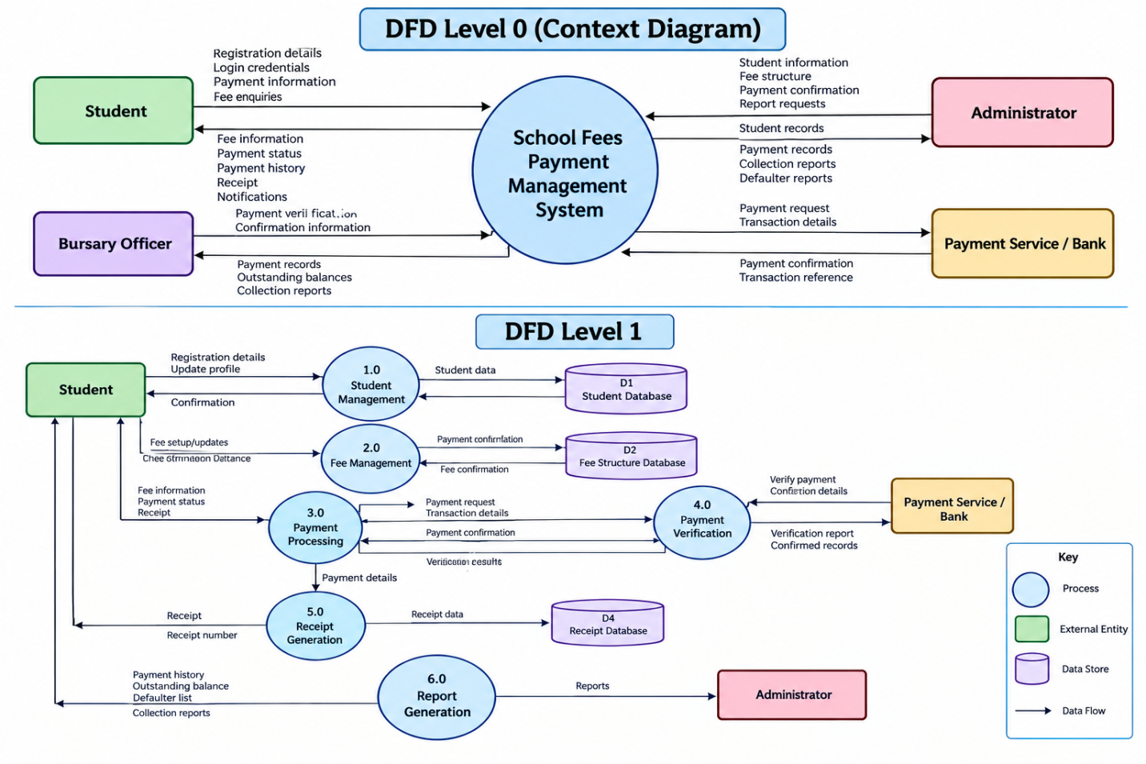
The Data Flow Diagram illustrates how information moves between users, processes, and the database.

3.2.5 Entity Relationship Diagram (ERD)
The Entity Relationship Diagram represents the logical relationship among the major data entities in the system.
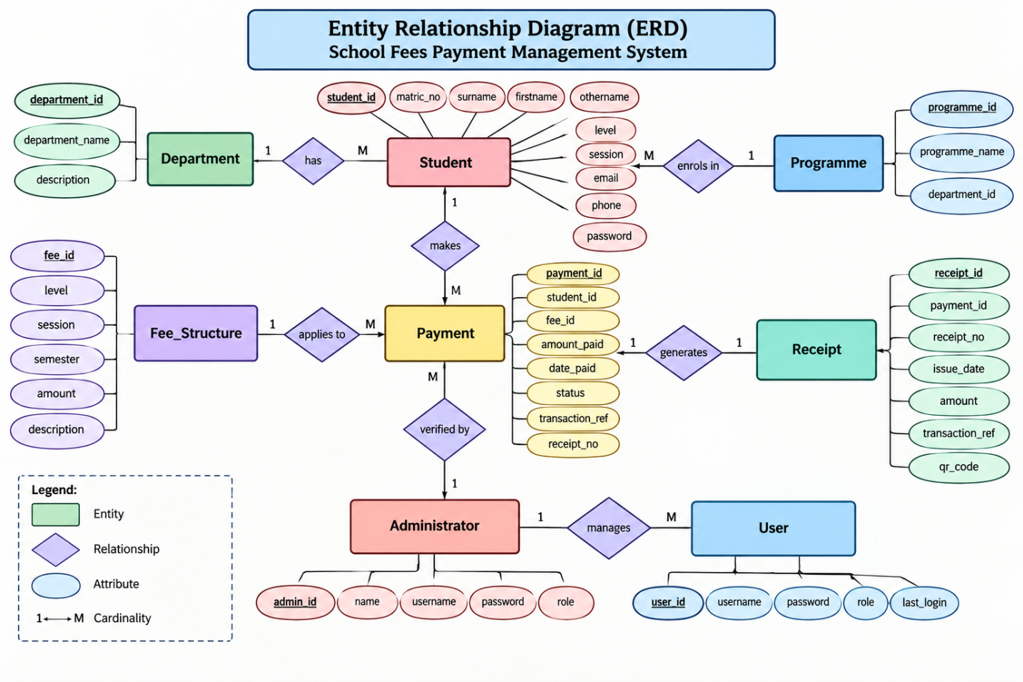

The major entities are:

Student
Attributes:
- Student_ID
- Matric_No
- Surname
- Firstname
- Othername
- Department
- Programme
- Level
- Session
- Email
- Phone
- Password

Department
Attributes:
- Department_ID
- Department_Name

Fee Structure
Attributes:
- Fee_ID
- Level
- Session
- Semester
- Amount
- Description

Payment
Attributes:
- Payment_ID
- Student_ID
- Fee_ID
- Amount_Paid
- Payment_Date
- Payment_Status
- Transaction_Reference
- Receipt_No

Administrator
Attributes:
- Admin_ID
- Name
- Username
- Password
- Role

Relationships
- One department can have many students.
- One student can have many payment records.
- One fee structure can apply to many students.
- One student can have different payment records for different sessions or semesters.
- An administrator can verify many payments.
- A payment generates one receipt.

3.3 Analysis of the Proposed System
The proposed system was analysed based on the required inputs, processing activities, outputs, database requirements, security requirements, and user requirements.

3.3.1 Input
Input refers to information supplied to the system for processing.
Major inputs include:

Student Input
- Matriculation number.
- Name.
- Department.
- Programme.
- Level.
- Session.
- Email.
- Telephone number.
- Password.

Fee Input
- Fee category.
- Academic session.
- Semester.
- Level.
- Amount payable.
- Description.

Payment Input
- Student identification.
- Fee identification.
- Amount paid.
- Payment date.
- Transaction reference.
- Payment method.

Administrator Input
- Username.
- Password.
- Student information.
- Fee structure.
- Payment confirmation.
- Report request.

3.3.2 Processing
After information is entered, the system processes the data according to predefined rules.
The major processing activities are:
- Validate user information.
- Authenticate user.
- Retrieve student information.
- Retrieve applicable fee.
- Calculate amount paid.
- Calculate outstanding balance.
- Determine payment status.
- Store transaction.
- Generate receipt number.
- Update payment record.
- Generate requested reports.

3.3.3 Output
The proposed system produces the following outputs:

Student Outputs
- Student dashboard.
- Fee information.
- Payment status.
- Payment history.
- Outstanding balance.
- Electronic receipt.

Administrative Outputs
- Student list.
- Payment report.
- Daily collection report.
- Semester collection report.
- Defaulter list.
- Outstanding balance report.
- Fully paid student report.
- Part-payment report.
The original project identifies payment receipts, defaulter lists, and daily collection reports as major system outputs.

3.3.4 Database
The database is the central storage component of the proposed system. It allows information to be stored, retrieved, updated, and managed systematically.
3.4 System Design
The system design translates the requirements identified during system analysis into a technical structure that can be implemented using software and database technologies.
The design incorporates Unified Modelling Language (UML) tools to represent system behaviour and interaction.
The major UML diagrams used are:
- Use Case Diagram.
- Activity Diagram.
- Sequence Diagram.
- Class Diagram.
3.4.1 Use Case Diagram
The Use Case Diagram describes the interaction between system users and the proposed system.
Actors
Student
The student can:
- Register.
- Login.
- View fee structure.
- Make payment.
- View payment history.
- Check payment status.
- Print receipt.
Administrator
The administrator can:
- Login.
- Manage students.
- Manage fee structures.
- View payments.
- Verify payments.
- Generate reports.
- Manage users.
- Backup database.
Bursary Officer
The bursary officer can:
- Login.
- View payment records.
- Verify payments.
- Confirm transactions.
- Generate financial reports.

